Renju lesson on September 27, 2001
Hello everyone! Welcome to Online Renju Class. We will now begin. Today we will continue the study of i8 opening. Last week, we studied the 4th move, suggested by yusuke_o. What is the most urgent 4th move you want to learn this time?
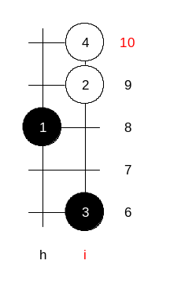
All right, most of you chose 4-i10, so be it. ☺

It is one of the strongest moves for white. Black needs to have lots of knowledge and skill to win here. I am not even sure if I know 100% sure win here. Probably I would try to find it in the real game. Speaking of 5th moves, do you know them? Wow, many of you know 5-g9.
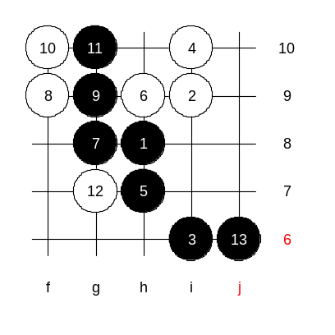
Indeed, 5-h7 is black sure win. Lets begin with it. After the 9th move black has god very strong position. Passive play is hopeless here, so white should try an active control style. How?

Black wins with the final control move! White is chained.
No matter where white plays, it is all under black’s control.
Look at the last move, j6. Why there? Why not i7?
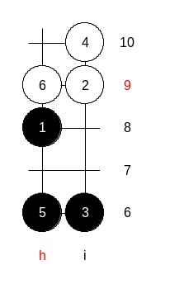
In fact, perhaps i7 and i8 are black win moves too, but we follow the principle of space move, and play j6, that makes the winning easier.

Let us discuss about the alternative 5th move now. Once again, let us repeat.
Those who have studied d11 very deeply, they can use 5-h6 here.
Move 6-h9 is forced the only move. The following is all well known already.
So, without knowing much about 4-i10, you are already prepared for it, having two 5th moves in the pocket.
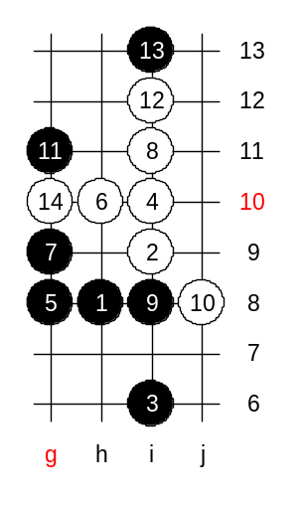

Now, one interesting 5th move, 5-g8. I analysed it many years ago, but I do not have the sure conclusion for that. White plays 6-h10. (if 6-i8 then 7-i11 and black surrounds white). Now, what can black do? Put your brain to work. Most of you say g9, lets go. Now white win. Who finds first? Yes, i11. ☺ That is a typical win in case of two triangles.

Lets try to find better 7th move. Any suggestions? Most of you say g10, lets go!
Move 8-g11 seems to give white advantage, but I am not sure it is enough for white win. What is better white move? Focus on control style please.
Since we could not find any active move, so we must use the backup move 8-g11.
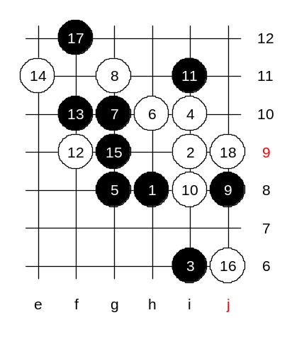
Database says 14-g9? Why? Is that necessary? Oh, because you are afraid of black’s VCF threat. So what? Let us go 14-e11 and let black take the g9 point which we will simply block from j6. And if black chooses 15-j6 instead, then 16-g9 and black cannot block from the right side because of white VCF on the left.
Now, 18 stones on the board, white main trap is to attack the 3x3 at point h12. Do you see it? So what can black do about it? If 19-k8 then will be 3x3 at L9. The stones at g9 and j6 do not influence white win in any way.

The conclusion: This 5th move leads to chaotic position. It is hard to tell whose advantage it is. It requires further research.

